1951040080-Lê Thành Tâm-Dv19

Câu 1:

a)

code

def KT(arr):

    count =0

    for i in arr:

        if(i<2):

            count=count+1

        else:

            for j in range (2,i-1):

                if(i%j==0 and j<i):

                    count= count+1

                    break

    return len(arr)-count

a= [1,2,3,4]

print(KT(a))

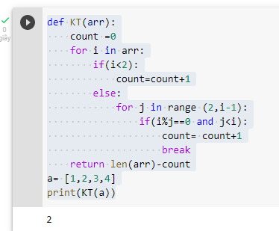

b)

- Mảng không có số nguyên tố

Code

Phần 2

Câu 1

Câu 2

a) SELECT SUM(commission), city FROM salesman GROUP BY city;

b) select * from customer c join salesman s on c.salesman_id = s.salesman_id where s.commission > 0.12 order by s.commission